Unit 2 : Advance SQL

Que 1: SET Operations in SQL
SQL supports few Set operations which can be performed on the table data. These are used to get meaningful results from data stored in the table, under different special conditions.
In this tutorial, we will cover 4 different types of SET operations, along with example:
- UNION
- UNION ALL
- INTERSECT
- MINUS

UNION Operation
- UNION is used to combine the results of two or more SELECT statements. However it will eliminate duplicate rows from its result set. In case of union, number of columns and datatype must be same in both the tables, on which UNION operation is being applied.
- The SQL Union operation is used to combine the result of two or more SQL SELECT queries.
- In the union operation, all the number of datatype and columns must be same in both the tables on which UNION operation is being applied.
- The union operation eliminates the duplicate rows from its resultset.

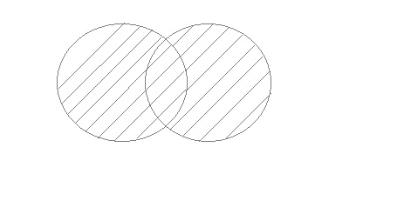
Syntax:

SELECT expression1, expression2, ... expression_n
FROM table1
WHERE conditions

UNION

SELECT expression1, expression2, ... expression_n
FROM table2
WHERE conditions;

Parameters:
- expression1, expression2, ... expression_n: It specifies the columns that you want to retrieve.
- table1, table2: it specifies the tables from where you retrieve the records.
- Conditions: it specifies the conditions that must be fulfilled for the records to be selected.
Note: The number of expressions must be same in both of the SELECT statements.
Table Name:First

ID | Name
1 | abhi
2 | adam

Table Name: Second

ID | Name
2 | adam
3 | Chester

Example:
SELECT * FROM First
UNION
SELECT * FROM Second

Output:

ID | NAME
1 | abhi
2 | adam
3 | Chester

UNION ALL
- This operation is similar to Union. But it also shows the duplicate rows.
- Union All operation is equal to the Union operation. It returns the set without removing duplication and sorting the data.
- The UNION ALL operator is used to combine the result sets of 2 or more SELECT statements. It is different from UNION operator in a way that it does not remove duplicate rows between the various SELECT statements. It returns all of the rows.
- Each SELECT statement within the UNION ALL must have the same number of fields in the result sets with similar data types

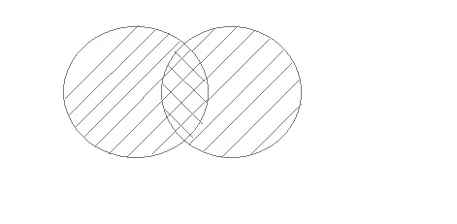
Syntax:
SELECT expression1, expression2, ... expression_n
FROM table1
WHERE conditions

UNION ALL

SELECT expression1, expression2, ... expression_n
FROM table2
WHERE conditions;

Parameters
- expression1, expression2, expression_n: It specifies the columns that you want to retrieve. Number of expressions must be same in both SELECT statements.
- table1, table2: It specifies the table name that you want to retrieve records from.
- conditions: It specifies the conditions that must be fulfilled for the records to be selected

Table Name:First

ID | Name
1 | abhi
2 | adam

Table Name:Second

ID | Name
2 | adam
3 | Chester

Example:
SELECT * FROM First UNION ALL SELECT * FROM Second;

Output:
ID | NAME
1 | abhi
2 | adam
2 | adam
3 | Chester

INTERSECT
- Intersect operation is used to combine two SELECT statements, but it only retuns the records which are common from both SELECT statements. In case of Intersect the number of columns and datatype must be same.

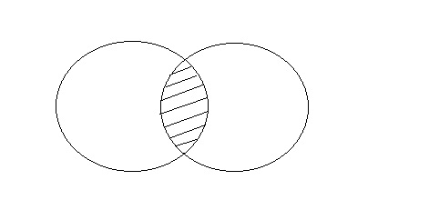

Syntax:
SELECT expression1, expression2, ... expression_n
FROM table1
WHERE conditions

INTERSECT

SELECT expression1, expression2, ... expression_n
FROM table2
WHERE conditions;

Parameters
- expression1, expression2, ... expression_n: It specifies the columns that you want to retrieve.
- table1, table2: It specifies the tables that you want to retrieve records from.
- conditions: it specifies the conditions that must be fulfilled for the records to be selected.

Table Name:First

ID | Name
1 | abhi
2 | adam

Table Name:Second

ID | Name
2 | adam
3 | Chester

Example:
SELECT * FROM First
INTERSECT
SELECT * FROM Second;

Output:
ID | NAME
2 | adam

MINUS
- The Minus operation combines results of two SELECT statements and return only those in the final result, which belongs to the first set of the result.
- It combines the result of two SELECT statements. Minus operator is used to display the rows which are present in the first query but absent in the second query.
- It has no duplicates and data arranged in ascending order by default.
- MINUS operator is used to return all rows in the first SELECT statement that are not returned by the second SELECT statement.
- Each SELECT statement has a dataset and the MINUS operator returns all documents from the first dataset and then removes all documents from the second dataset.

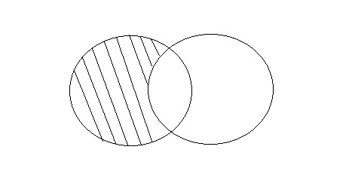

Syntax:
SELECT expression1, expression2, ... expression_n
FROM table1
WHERE conditions

minus

SELECT expression1, expression2, ... expression_n
FROM table2
WHERE conditions;

Parameters
- expression1, expression2, ... expression_n: It specifies the columns that you want to retrieve.
- table1, table2: it specifies the tables that you want to retrieve records from.
- conditions: it specifies the conditions that must be fulfilled for the records to be selected.

Table Name:First

ID | Name
1 | Abhi
2 | Adam

Table Name:Second
ID | Name
2 | Adam
3 | Chester

Example:
SELECT * FROM First
MINUS
SELECT * FROM Second;

Output:

ID | NAME
1 | Abhi

Que 2: Explain JOIN

What is join?
- Join is a query that is used to combine rows from two or more tables, views, or materialized views. It retrieves data from multiple tables and creates a new table.
- Joins help retrieving data from two or more database tables.
- The tables are mutually related using primary and foreign keys.

Types of joins
- Inner Joins (Simple Join, Self Joins)
- Outer Joins
  - Left Outer Join (Left Join)
  - Right Outer Join (Right Join)
  - Full Outer Join (Full Join)
- Equijoins
- Cross Joins (Cartesian Products)
  - Inner Joins (Simple Join)
- Inner Join is the simplest and most common type of join. It is also known as simple join. It returns all rows from multiple tables where the join condition is met.
Syntax:

SELECT columns
FROM table1
INNER JOIN table2
ON table1.column = table2.column;

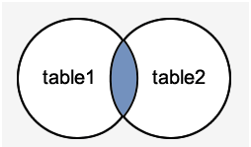

Table name: student
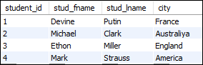

Table Name: technologies
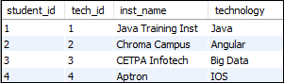

Query:
SELECT students.stud_fname, students.stud_lname, students.city, technologies.technology
FROM students
INNER JOIN technologies
ON students.student_id = technologies.tech_id;

OutPut:
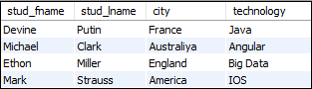

  - Outer Joins
- Outer Join is based on both matched and unmatched data. Outer Joins subdivide further into,
- Left Outer Join
- Right Outer Join
- Full Outer Join
- Left Outer Join:
- The left outer join returns a result set table with the matched data from the two tables and then the remaining rows of the left table and null from the right table's columns.
- The LEFT JOIN keyword returns all records from the left table (table1), and the matching records from the right table (table2). The result is 0 records from the right side, if there is no match.
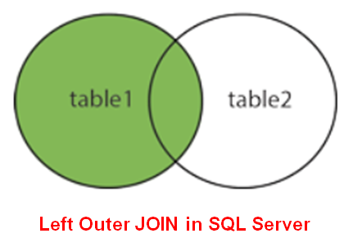
Syntax:
SELECT column_name(s)
FROM table1
LEFT JOIN table2
ON table1.column_name = table2.column_name;
Table Name: CUSTOMER
ID | NAME | AGE | SALARY
1 | ARYAN | 51 | 56000
2 | AROHI | 21 | 25000
3 | VINEET | 24 | 31000
4 | AJEET | 23 | 32000
5 | RAVI | 23 | 42000

Table Name: ORDER
O_ID | DATE | CUSTOMER_ID | AMOUNT
001 | 20-01-2012 | 2 | 3000
002 | 12-02-2012 | 2 | 2000
003 | 22-03-2012 | 3 | 4000
004 | 11-04-2012 | 4 | 5000
Example:
SELECT ID, NAME, AMOUNT, DATE FROM CUSTOMER LEFT JOIN ORDER ON CUSTOMER.ID = ORDER.CUSTOMER_ID;
OutPut:

ID | NAME | AMOUNT | DATE
1 | ARYAN | NULL | NULL
2 | AROHI | 3000 | 20-01-2012
2 | AROHI | 2000 | 12-02-2012
3 | VINEET | 4000 | 22-03-2012
4 | AJEET | 5000 | 11-04-2012
5 | RAVI | NULL | NULL

- Right Outer Join
- The SQL right join returns all the values from the rows of right table. It also includes the matched values from left table but if there is no matching in both tables, it returns NULL.

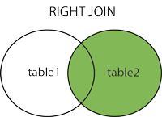
Syntax:
SELECT table1.column1, table2.column2.....
FROM table1
RIGHT JOIN table2
ON table1.column_field = table2.column_field;
Table Name: CUSTOMER

ID | NAME | AGE | SALARY
1 | ARYAN | 51 | 56000
2 | AROHI | 21 | 25000
3 | VINEET | 24 | 31000
4 | AJEET | 23 | 32000
5 | RAVI | 23 | 42000

Table Name: ORDER
O_ID | DATE | CUSTOMER_ID | AMOUNT
001 | 20-01-2012 | 2 | 3000
002 | 12-02-2012 | 2 | 2000
003 | 22-03-2012 | 3 | 4000
004 | 11-04-2012 | 4 | 5000

Example:
SELECT ID, NAME, AMOUNT, DATE
FROM CUSTOMER
Right JOIN ORDER
ON CUSTOMER.ID = ORDER.CUSTOMER_ID;
Output:
ID | NAME | AMOUNT | DATE
2 | AROHI | 3000 | 20-01-2012
2 | AROHI | 2000 | 12-02-2012
3 | VINEET | 4000 | 22-03-2012
4 | AJEET | 5000 | 11-04-2012

- Full Outer Join
- The SQL full join is the result of combination of both left and right outer join and the join tables have all the records from both tables. It puts NULL on the place of matches not found.
- SQL full outer join and SQL join are same. Generally it is known as SQL FULL JOIN.
- SQL full outer join is used to combine the result of both left and right outer join and returns all rows (don't care its matched or unmatched) from the both participating tables.
- The FULL OUTER JOIN keyword returns all records when there is a match in left (table1) or right (table2) table records. Tip: FULL OUTER JOIN and FULL JOIN are same
. 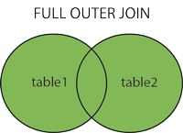
Syntax:
SELECT *
FROM table1
FULL OUTER JOIN table2
ON table1.column_name = table2.column_name;
Table Name: Class
ID | NAME
1 | abhi
2 | adam
3 | alex
4 | anu
5 | ashish

Table Name: class_info

ID | Address
1 | DELHI
2 | MUMBAI
3 | CHENNAI
7 | Noida
8 | panipat

Example:
SELECT *
FROM class
FULL OUTER JOIN class_info
ON (class.id = class_info.id);

Output:
ID | NAME | ID | Address
1 | abhi | 1 | DELHI
2 | adam | 2 | MUMBAI
3 | alex | 3 | CHENNAI
4 | anu | null | null
5 | ashish | null | null
null | null | 7 | NOIDA
null | null | 8 | PANIPAT

3) Equijoins
- The process is called joining when we combine two or more tables based on some common columns and a join condition. An equijoin is an operation that combines multiple tables based on equality or matching column values in the associated tables.
- We can use the equal sign (=) comparison operator to refer to equality in the WHERE clause. This joining operation returns the same result when we use the JOIN keyword with the ON clause and then specifying the column names and their associated tables.
- Equijoin is a classified type of inner join that returns output by performing joining operations from two tables based on the common column that exists in them. This join returns only those data that are available in both tables based on the common primary field name. It does not display the null records or unmatchable data into the result set.

Syntax:
The following are the basic syntax that illustrates the equijoin operations:
SELECT column_name (s)
FROM table_name1, table_name2, ...., table_nameN
WHERE table_name1.column_name = table_name2.column_name;
OR
SELECT (column_list | *)
FROM table_name1
JOIN table_name2
ON table_name1.column_name = table_name2.column_name;

In this syntax, we need to specify the column names to be included in the result set after the SELECT keyword. If we want to select all columns from both tables, the * operator will be used. Next, we will specify the table names for joining after the FROM keyword, and finally, write the join condition in the WHERE and ON clause.
Table Name: Customer
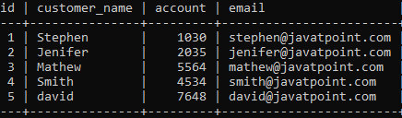

Table Name: Balance
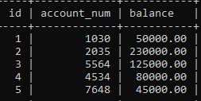
Example:
SELECT customer. customer_name, balance. balance
FROM customer, balance
WHERE customer.account = balance.account_num;

Output:
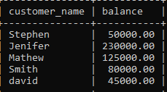
  - Cross Joins
- MySQL CROSS JOIN is used to combine all possibilities of the two or more tables and returns the result that contains every row from all contributing tables. The CROSS JOIN is also known as CARTESIAN JOIN, which provides the Cartesian product of all associated tables. The Cartesian product can be explained as all rows present in the first table multiplied by all rows present in the second table. It is similar to the Inner Join, where the join condition is not available with this clause.
- We can understand it with the following visual representation where CROSS JOIN returns all the records from table1 and table2, and each row is the combination of rows of both tables.

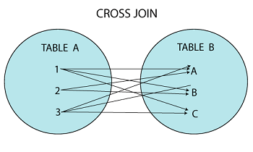
Syntax:
SELECT column-lists
FROM table1
CROSS JOIN table2;

Table: customers
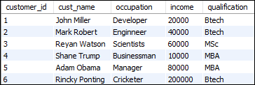
Table: contacts
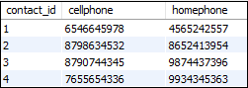
Example:
SELECT *
FROM customers
CROSS JOIN contacts;

OutPut:

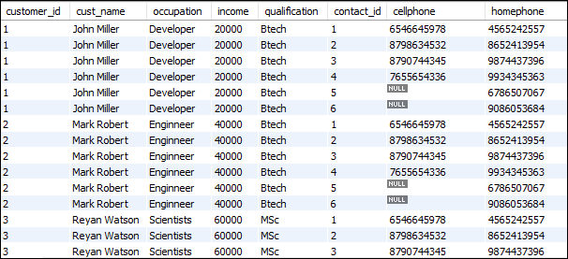

Que 3: SQL Function
- Date and Time

1) ADD_MONTHS
- Returns date after adding the number of months specified in the function
Syntax:
add_months(d,n)
Example:
Select add_months(sysdate,4) from dual;
Output:
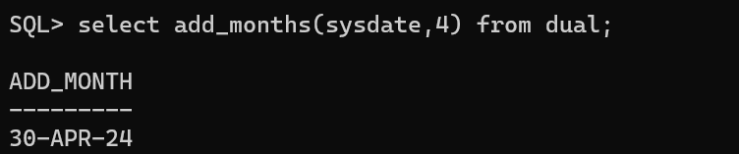
2) LAST_DAY ()
- Returns the last date of the month specified with the function.
Syntax:
Last_day(d)

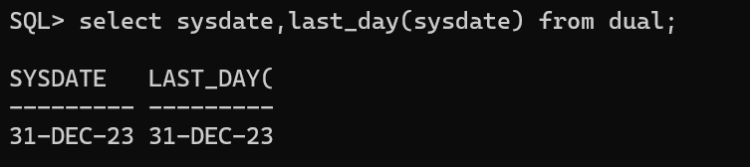
3) MONTHS_BETWEEN ()

Syntax:
Months_between(d1,d2)
- Returns number of months between d1 and d2.

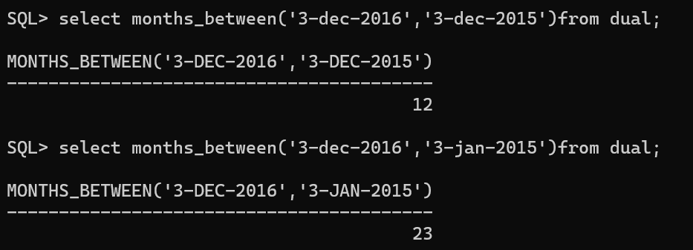
4) NEXT_DAY ()
- Returns the date of the first weekday name by char that is after the date named by date. Char must be a day of the week.
Syntax:
NEXT_DAY (date, char)
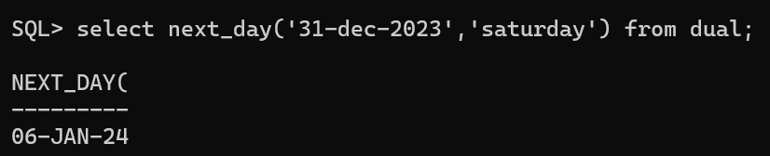
5) CURRENT_DATE ()
    - The CURRENT_DATE () is a ORACLE date/time function. It is used to get the current date.
Example:
Select CURRENT_DATE from dual;
Output:
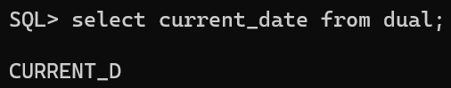
6) CURRENT_TIMEstamp ()
- The CURRENT_TIME () is a ORACLE date/time function. It is used to get the current time.
Example:
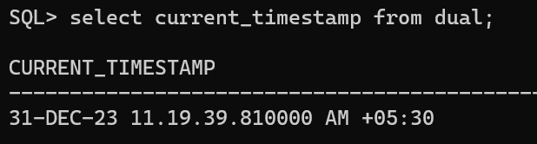
8) EXTRACT ()
    - Extract a value of a date time field e.g., YEAR, MONTH, and DAY, from a date time value.
Example:
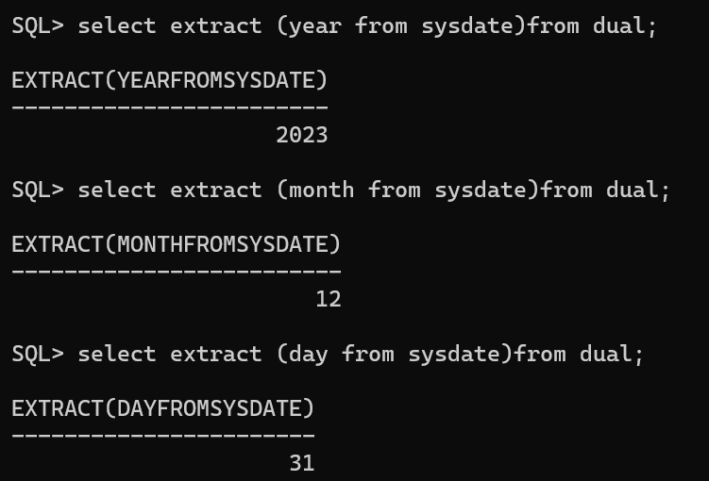
9) TO_DATE ()
    - Convert a date which is in the character string to a DATE value.
Example:
Select TO_DATE (‘01 Jan 2017', 'DD MON YYYY’) from dual;

Output:
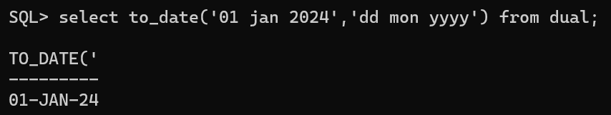
2) Numeric
    - ABS():Returns the absolute value of a number
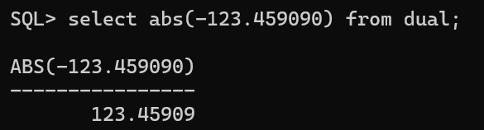
    - AVG(column_name):Returns the average of a column of numbers

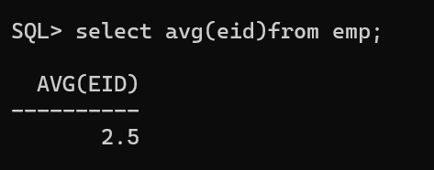
    - CEIL(value): Smallest integer greater than or equal to a decimal value
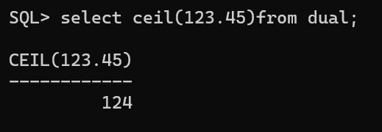
    - Floor(value): Returns the largest integer less than or equal to a decimal value
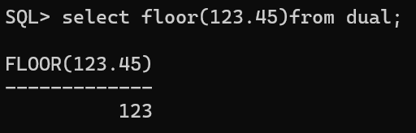
    - COUNT(value): The number of rows returned by a query
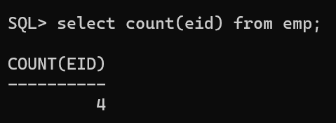
    - Least(value1,value2…value..n): Returns the smallest of multiple values
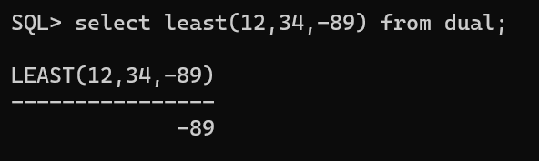
    - Greatest(value1,value2…value..n): Returns the largest of multiple values
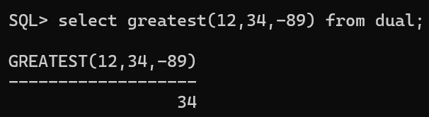
    - Length(value): Returns length in characters
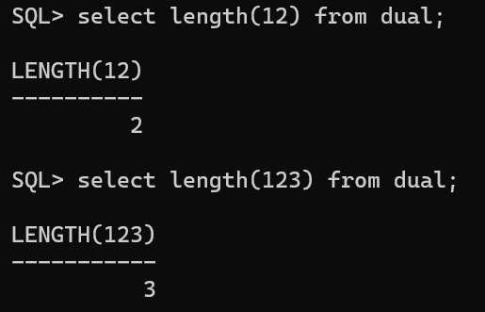
    - Max(column name): Returns the maximum value returned by a query
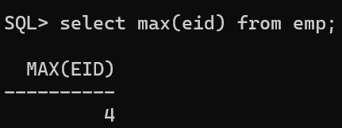
    - Min(column name): Returns the minimum value returned by a query
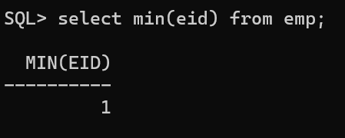
    - Mod(m_value,n_value): Returns the modulus of a number. Same as remainder
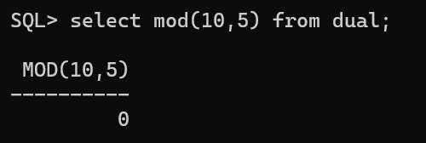
    - Power(m_value,n_value): Returns m_value raised to the n_value power
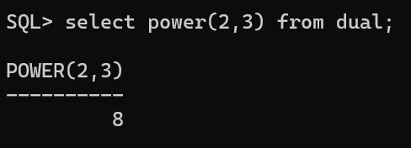
    - Sum(column name): Computes the sum of an expression
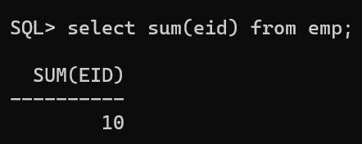
    - Trunc(<value>, <decimal_places>): The TRUNC function can reduce the precision of its first numeric

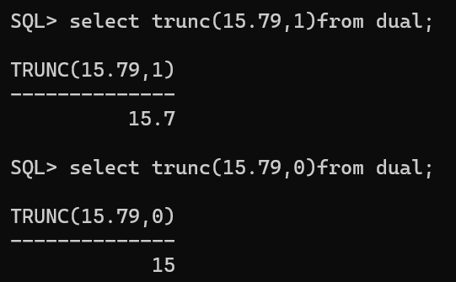

3) String

1) Ascii ():
This function is used to find the ASCII value of a character
Example:
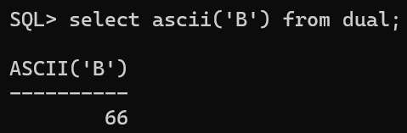

2) CHR
CHR is a String function of Oracle. This function returns all the characters of the given ASCII code.

Example:
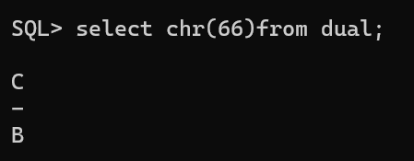
3) CONCAT
CONCAT is a String function of Oracle. This function returns a string by concatenating all the arguments. It can have more than one argument.

Example:
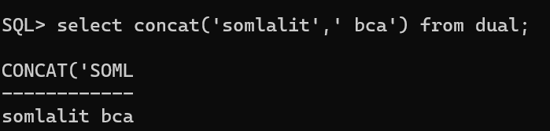

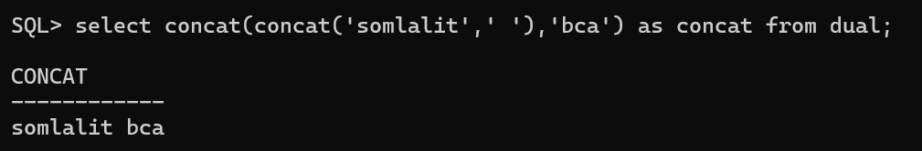
4) LENGTH()
LENGTH is a String function of Oracle. This function returns the size of the given string.
Example
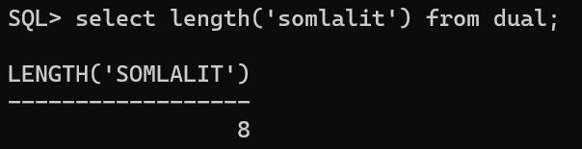
5) LOWER(‘string’)
LOWER is a String function of Oracle. This function returns the given string into the lower case.
Example
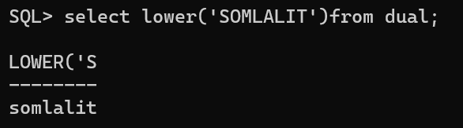

6) UPPER(‘string’)
UPPER is a String function of Oracle. This function is used to convert the given string into uppercase.
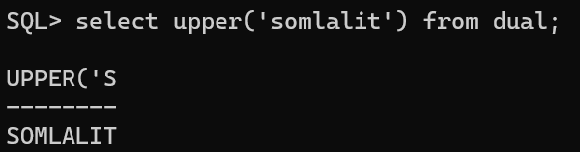
7) LPAD ()
LPAD is a String function of Oracle. This function returns the left padded to the given length.
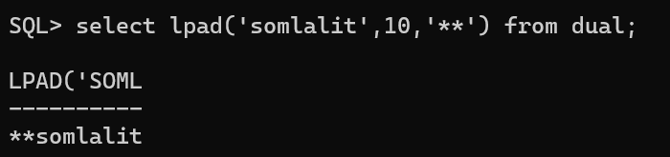
8) RPAD ()
RPAD is a String function of Oracle. This function returns the right-padded to the given length.
Example

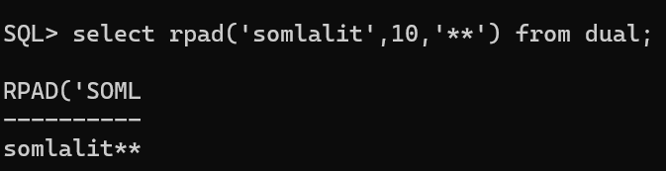
Output:

9) LTRIM()
LTRIM(str) is a String function of Oracle. This function returns the string by removing given characters from left side.
Example
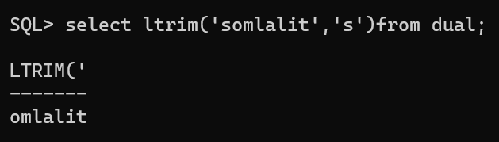
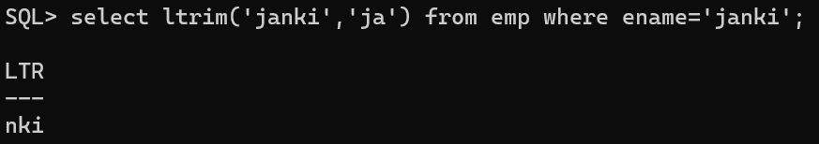
10) RTRIM()
RTRIM(str) is a String function of Oracle. This function returns the string by removing given characters from the right side.

Example
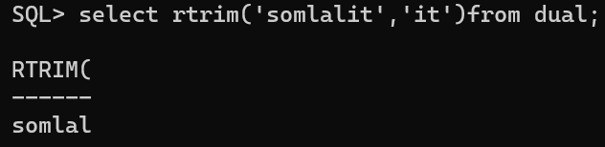
11) REPLACE()
REPLACE is a String function of Oracle. This function is used to replace the sequence of character with another character in the given string.
Example
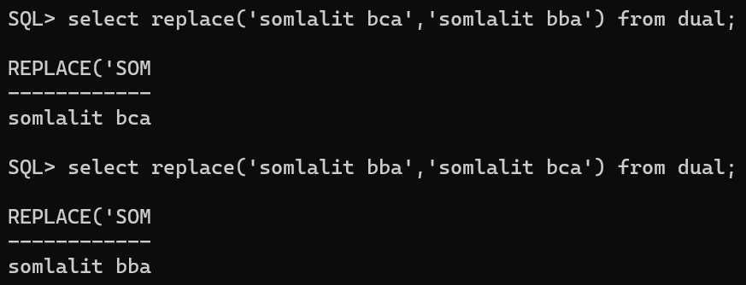
12) SUBSTR()
SUBSTR is a String function of Oracle. This function is used to extract the sub string from the given string
Example
SELECT SUBSTR('oracle', 2, 4) FROM dual;
Output:
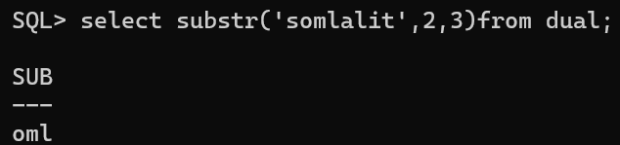
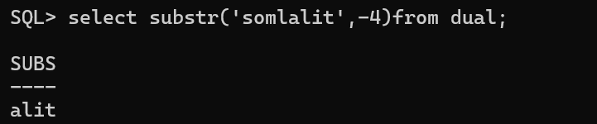
13) TRANSLATE()
TRANSLATE is a String function of Oracle. This function is used to replace the character from the given character. This function replaces one character only.
Example
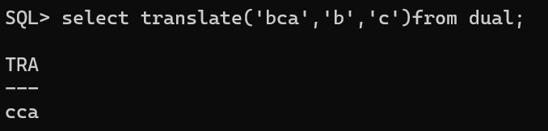
4)Conversion Function
you can use conversion functions to convert data from one type to another.

1) TO_CHAR Function:
Converts a date or timestamp to a character string.
SYNTAX:
TO_CHAR(date, format)
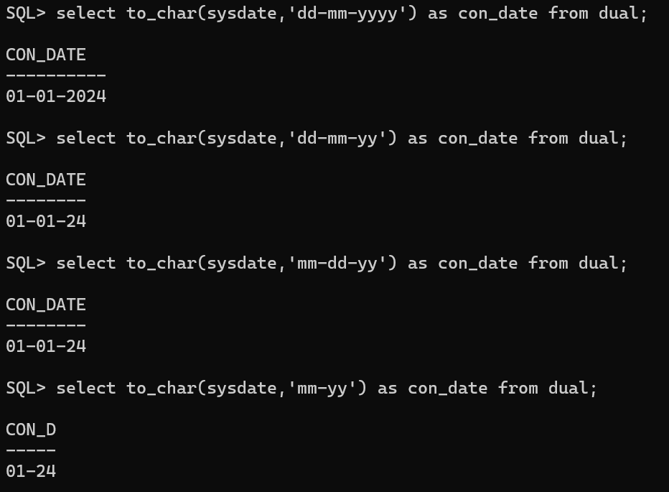
2)TO_DATE ()
Syntax:TO_DATE(string, format)
Converts a character string to a date.
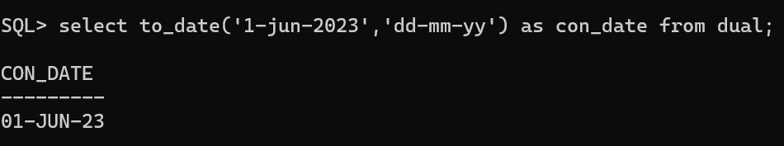
3) TO_NUMBER ()
Converts a character string to a number.

Syntax
TO_NUMBER (string1)
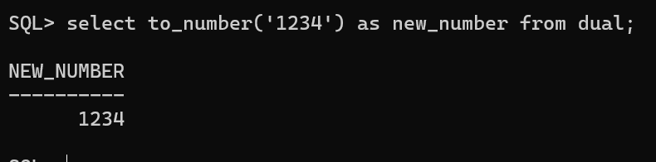

Que 4: Explain SUB QUERY
- subqueries are the queries inside a query. Subqueries can be made using WHERE, FROM or SELECT clause.
- A subquery in oracle is a query, which is nestled into another oracle query and embedded with SELECT, INSERT, UPDATE or DELETE statement along with the various operators.
- We can also nest the subquery with another subquery.
- A subquery is known as the inner query, and the query that contains subquery is known as the outer query.
- The inner query executed first gives the result to the outer query, and then the main/outer query will be performed.
- oracle allows us to use subquery anywhere, but it must be closed within parenthesis.
The following are the rules to use subqueries:
- Subqueries should always use in parentheses.
- If the main query does not have multiple columns for subquery, then a subquery can have only one column in the SELECT command.
- We can use various comparison operators with the subquery, such as >, <, =, IN, ANY, SOME, and ALL. A multiple-row operator is very useful when the subquery returns more than one row.
- We cannot use the ORDER BY clause in a subquery, although it can be used inside the main query.
- If we use a subquery in a set function, it cannot be immediately enclosed in a set function.

The following are the advantages of using subqueries:
- The subqueries make the queries in a structured form that allows us to isolate each part of a statement.
- The subqueries provide alternative ways to query the data from the table; otherwise, we need to use complex joins and unions.
- The subqueries are more readable than complex join or union statements.

Syntax
SELECT column_list (s) FROM table_name WHERE column_name OPERATOR
(SELECT column_list (s) FROM table_name [WHERE])
- Where Subqueries
- The most common type of subquery uses an inner SELECT subquery on the right side of a WHERE comparison expression.
Example:
to find all products with a price greater than or equal to the average product price, you write the following query
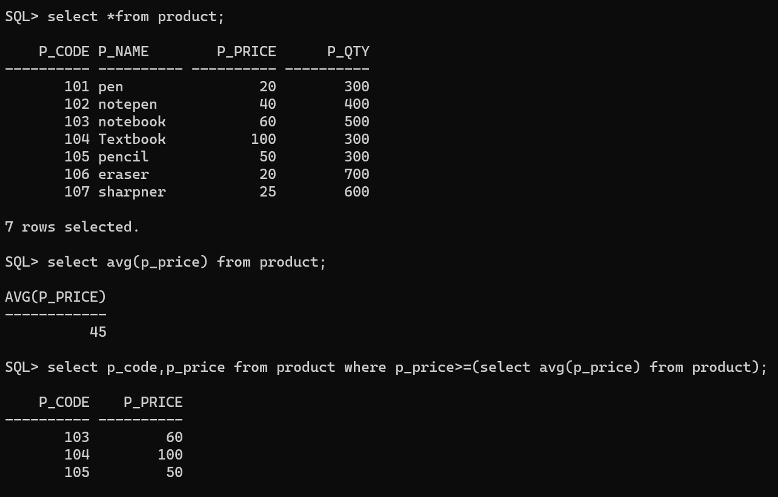
- In subqueries
The IN operator in SQL is commonly used in subqueries to compare a value against a set of values returned by a subquery. It is typically employed in the WHERE clause of a SQL statement.
Syntax
SELECT column1, column2 FROM table1 WHERE column3 IN (SELECT column4 FROM table2 WHERE condition);
Example
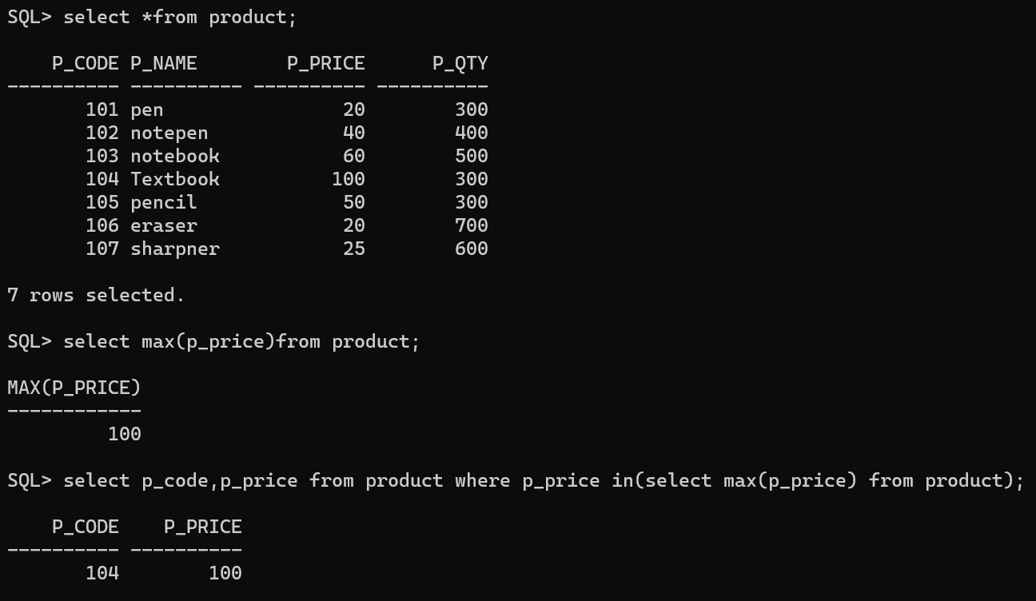
- Multirow subquery Operators : Any and All
A multirow subquery is a subquery that returns multiple rows of data, and it can be used with the ANY and ALL operators in SQL to compare a single value with a set of values returned by the subquery.
- With ANY, the condition is true if the specified condition is true for at least one value in the set.
- With ALL, the condition is true only if the specified condition is true for all values in the set.
These operators are useful when you need to perform comparisons against a set of values returned by a subquery instead of a single value.

Any operator
- The ANY operator is used to compare a value to any value in a set of values returned by a subquery.
Syntax
SELECT column_name FROM table_name WHERE column_name comparison_operator ANY (SELECT column_name FROM table_name WHERE condition);
Example
Find all Product whose Price is greater than any Price in the Product with Pcode is 101
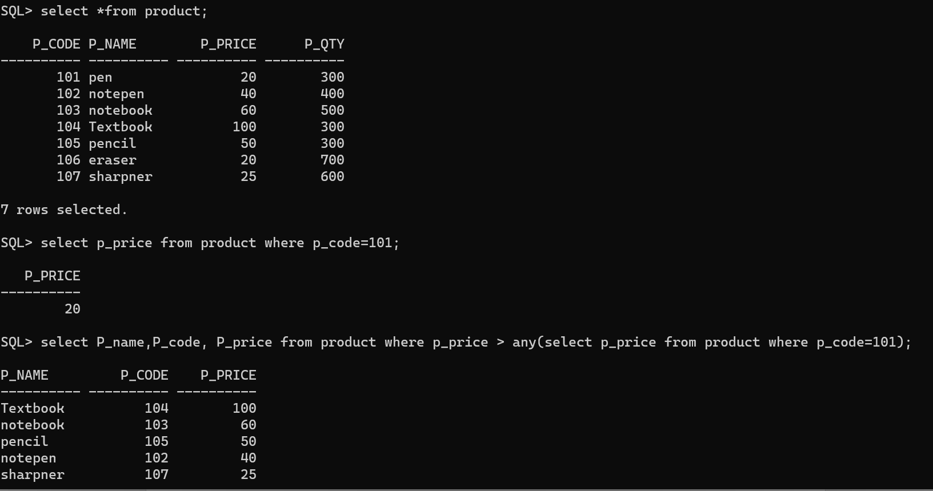
ALL Operator:
- The ALL operator is used to compare a value to all values in a set of values returned by a subquery.
- The syntax for using the ALL operator is similar to the ANY operator:
Syntax
SELECT column_name FROM table_name WHERE column_name comparison_operator ALL (SELECT column_name FROM table_name WHERE condition);
Example
Find all Products name whose totalprice is greater than all products in the product code with 102.
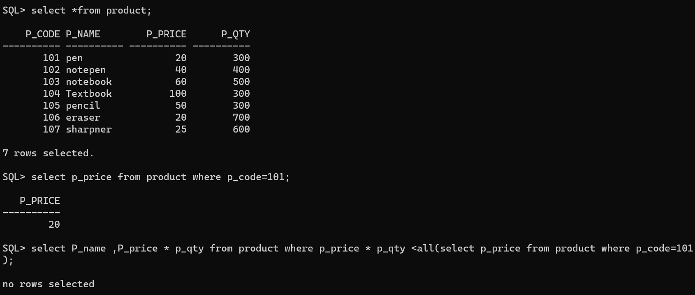
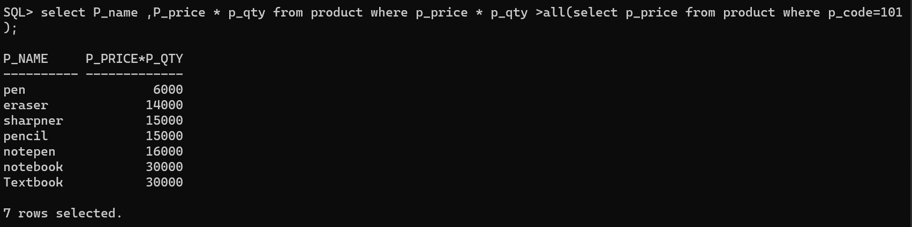
From Subqueries
- From clause can be used to specify a sub-query expression in SQL.
- The relation produced by the sub-query is then used as a new relation
On which the outer query is applied.
- The FROM clause specifies the table(s) from which the data will be drawn. Because the output of a SELECT statement is another table (or more precisely a “virtual” table), you could use a SELECT subquery in the FROM clause.
Syntax
SELECT column1 FROM (SELECT column1 FROM table1 WHERE condition) AS subquery_alias;
Example
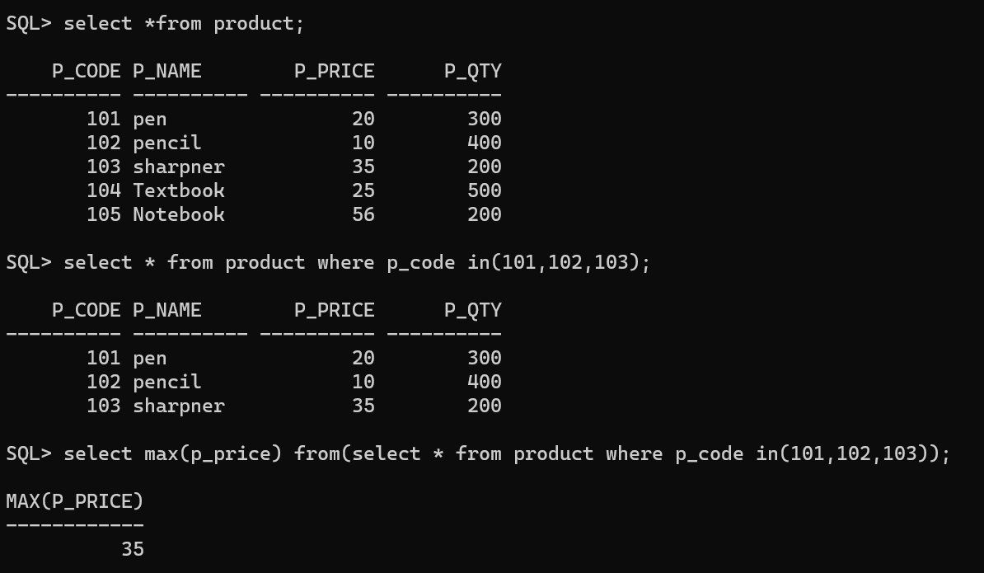
Attribute list subquery
- The SELECT statement uses the attribute list to indicate what columns to project in the resulting set.
- Those columns can be attributes of base tables, computed attributes, or the result of an aggregate function.
- The attribute list can also include a subquery expression, also known as an inline subquery.
- A subquery in the attribute list must return one single value; otherwise, an error code is raised.
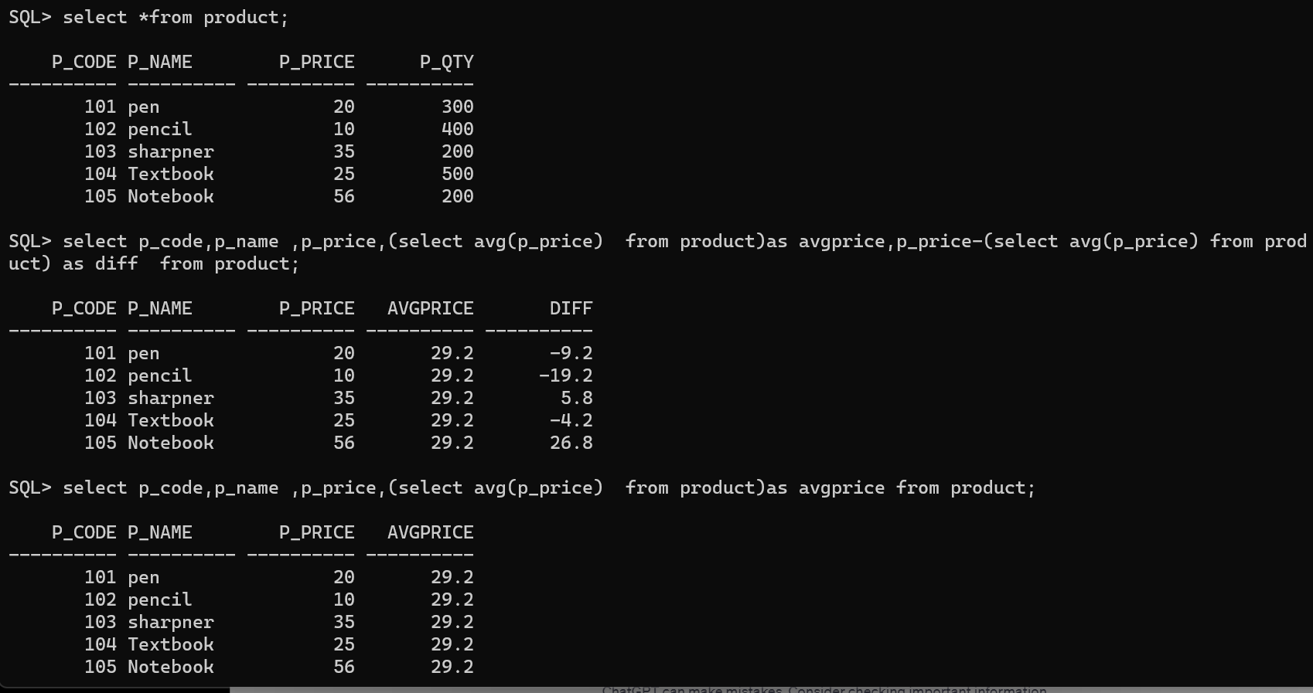

correlated subquery
- A correlated subquery in MySQL is a subquery that depends on the outer query.
- It uses the data from the outer query or contains a reference to a parent query that also appears in the outer query.
- MySQL evaluates it once from each row in the outer query.
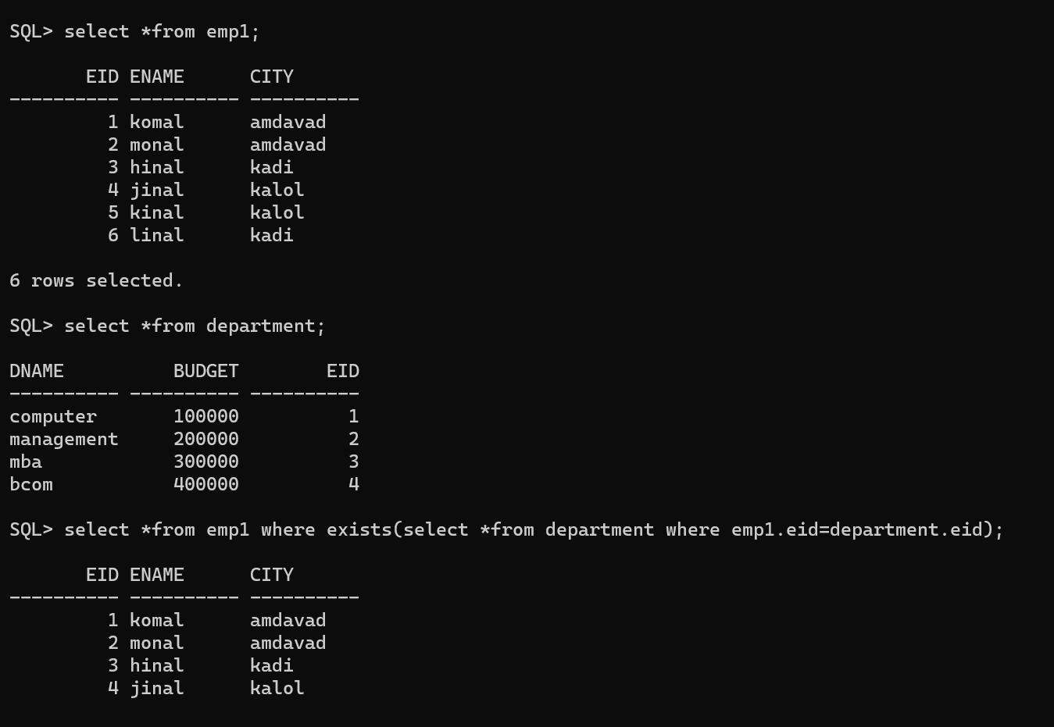

Que 5: Explain sequence
- a sequence is a database object that provides a way to generate a series of unique numeric values.
- Sequences are often used to generate primary key values for tables in a relational database.
- They provide an efficient and scalable method for generating unique identifiers.
- The basic idea is that you can create a sequence, and then retrieve the next value from the sequence whenever you need a new unique identifier.
- This is particularly useful in scenarios where multiple transactions or processes may need to insert records into a table, and you want to ensure that each record gets a unique identifier.
- The numeric values sequence that is generated can be in a descending or ascending order depending upon an already preset incremental value and it can also be started again (cycle) when it reaches its termination limit.
- Unlike identity columns, the sequences are not associated with some particular tables. In order to get the next value of the sequence generated, the applications can refer to an object of sequence.

Different Features of Sequences
- A sequence is a database object that generates and produces integer values in sequential order.
- It automatically generates the primary key and unique key values.
- It may be in ascending or descending order.
- It can be used for multiple tables.
- Sequence numbers are stored and generated independently of tables.
- It saves time by reducing application code.
- It is used to generate unique integers.
- It is used to create an auto number field.
- Useful when you need to create a unique number to act as a primary key.
- Oracle provides an object called a Sequence that can generate numeric values. The value generated can have maximum of 38 digits
- Provide intervals between numbers.

Syntax:
CREATE SEQUENCE sequence_name
START WITH initial_value
INCREMENT BY increment_value
MINVALUE minimum value
MAXVALUE maximum value
CYCLE|NOCYCLE ;

Example:
